Task 2 – Development Documentation

In my first iteration I have covered which is:

* Provide customers with help and information about the attractions and facilities

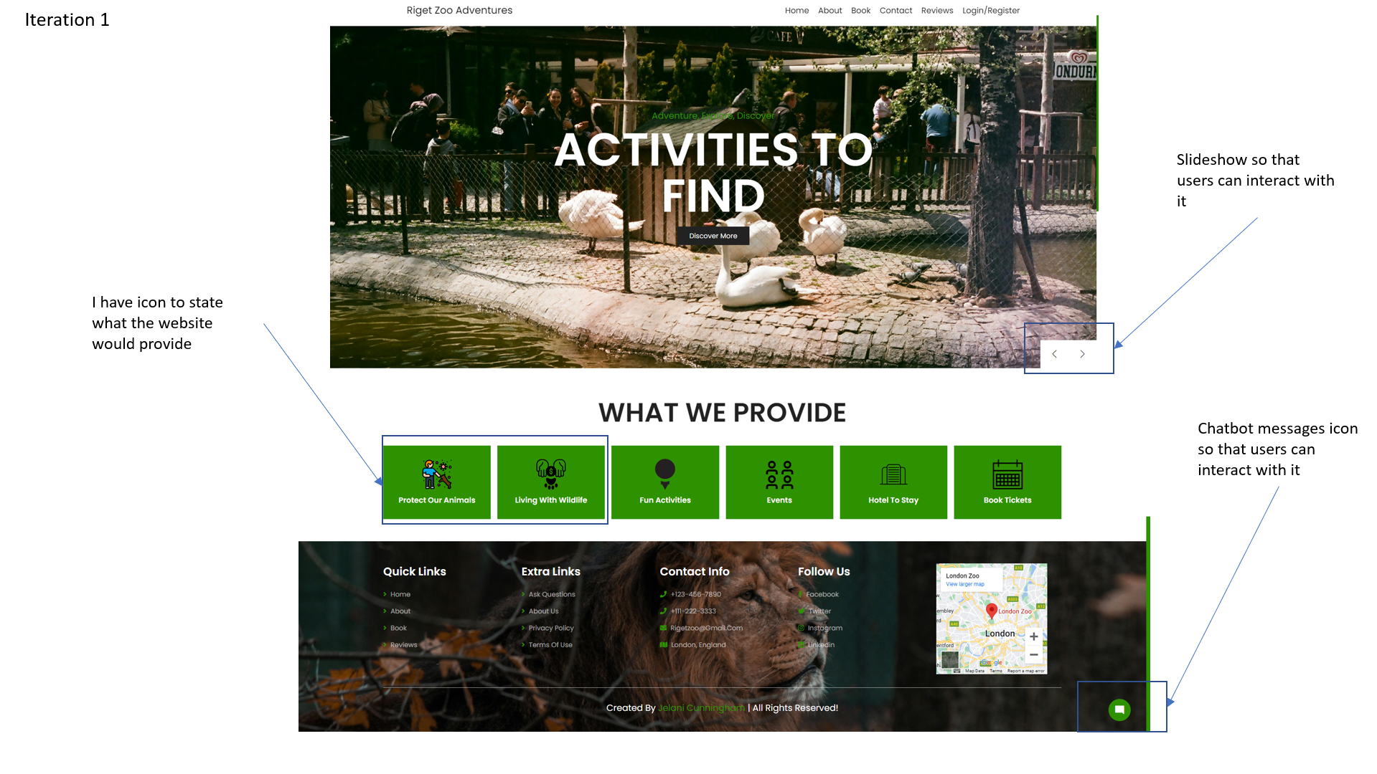

I've included a slideshow on my website to tell visitors more about the location and the opinions of the zoo. In order to provide you with more information, I have included the "discover more" button, which will take you to the "about us" page. I've included an indication of what the website will offer, such as events and activities that you may participate in. I've included a chatbot for people to utilize in case they need assistance or have any queries. I found the location of the zoo using the Google map API.

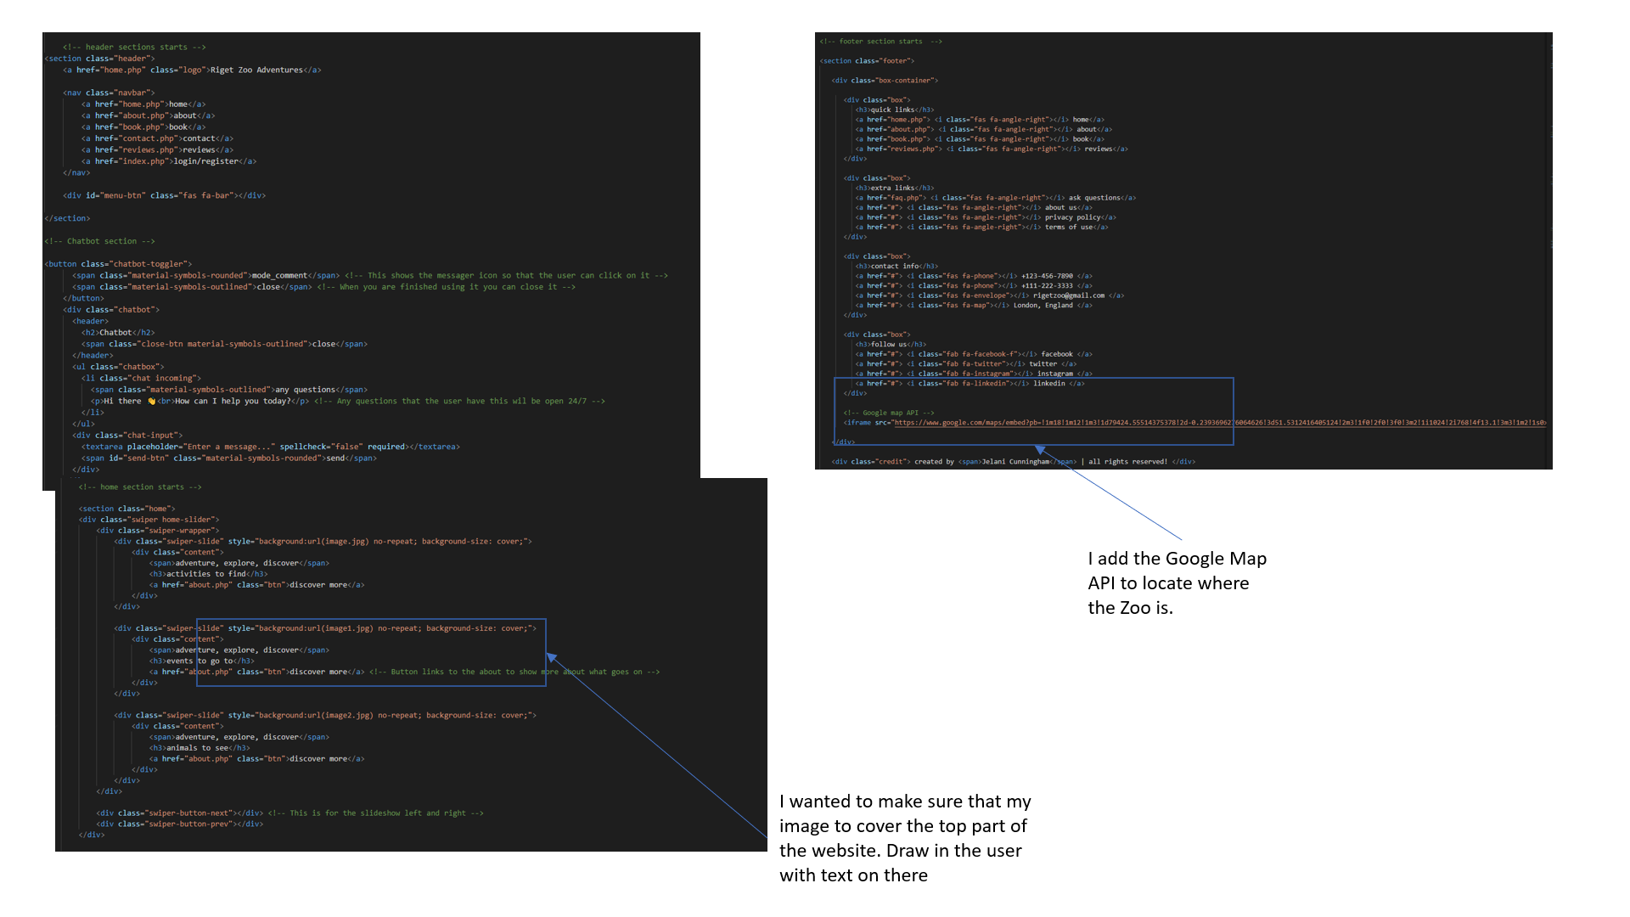

The programming languages that I used for the slideshow and the chatbot is JavaScript. The uses of the JavaScript of the slideshow are to show the user can interactive it to see the users of the images to portray the design and range of the different users. The use of the map API was to show the location of the zoo and so that you can go there.